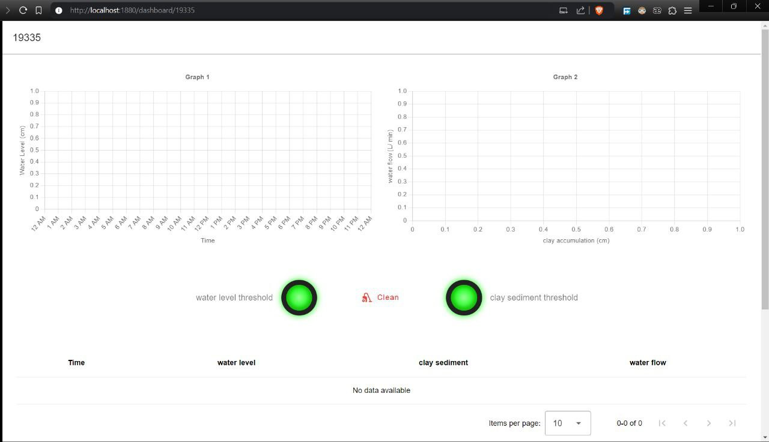The monitoring system is responsible for water management, that is achieved through three sensors: flow rate, ultrasonic sensor and water level. when precepted clay increase reaching the threshold 4 cm, the flow rate decreases. That indicates that clay must be removed. While the water level helps to decide to open / close the gates that passes water from channels to another channel depending on the defined water level threshold.

***Figure (1)***

The dashboard contains two graphs, two table and two buzzers. The first graph figure (1) in top left of screen has a time factor on its (X-axis) and water level factor on its (Y-axis). The left-middle buzzer indicates green when the value of water level is less than the 16 cm water level threshold. When the water level exceeds 16 cm threshold, the buzzer color will be shown in red color and triggers an alarm sound. Additionally, there is a table under the graph illustrates time and water level values, updating every 5 seconds.

***Figure (2)***

The second graph figure (2) in top right of screen has a clay height factor on its(X-axis )and flow rate factor on its (Y-axis). The right-middle buzzer indicates green when the value of clay height is less than the 4 cm clay height threshold. When the clay height exceeds 4 cm threshold, the buzzer color will be shown in red color and triggers an alarm sound. Additionally, there is a table under the graph illustrates clay height and flow rate values, updating every 5 seconds.